Request For Proposal (“RFP”) Non- Construction

Description: Pest Control Services
RFP Number: 022323 PEST CONTROL
Issue Date:
Proposal Due Date & Time: 2/23/23 @ 10:30am

The White Plains Housing Authority (WPHA) is soliciting proposals from qualified and insured vendors to provide Pest Control Services. All proposal submitted in response to this solicitation must conform to all of the requirement and specifications outlined within this document and any designated attachments in its entirety.

Scope of Work
Provide extermination services for properties owned and operated by White Plains Housing Authority as listed on Location of Work, Attachment C.

Common pest

- Inspect all units for the presence of insects or rodents, treat units to control infestation using most efficient and safe methodology.
- Bait common areas and building exteriors for rodent control as needed.
- Re-treat units as necessary to ensure proper pest control.

Bedbugs
- Provide extermination services for active units an surrounding units.
- The proposer will notify WPHA, in writing, of all units where the residents did not follow compliance order as well as units that are in the condition that would contribute to the proliferation of pests.
- Contractor must inspect and record the number of bedbugs seen.
- Discuss with management the most effective treatment options based on infestation size, level of clutter and square footage.

Inspection or treatment based on frequency of treatments listed below

Tasks and responsibilities noted above are inclusive of, but not limited to, the total project scope, some work will be performed on an urgent basis, and others may be performed on a routine basis.

Pricing
- Provide pricing for each location
- Indicate any initial setup costs; i.e. Bait Stations
- Provide monthly pricing for rodent and insect control.
- Provide separate pricing for bedbug & roach fogging

Frequency of treatments
Type Common Pests Bedbugs
Apartments Bi-Monthly As needed
Admin Building Bi-Monthly As needed
Offices Bi-Monthly As needed
Laundry Facilities Bi-Monthly As needed
Maintenance Areas Bi-Monthly As needed
Compactor Rooms Bi-Monthly As needed
Basement Baiting Monthly As needed

Profile of Firm Form
Attachment A must be completed and returned with proposal

Proposed Services

As more fully detailed within “Scope of Work” above, the proposer shall clearly detail the following:

- Submit a proposal plan including treatments to ensure the apartments and common areas will be free of bug and rodent infestations, including, but not limited to roaches, ants, rats, mice, silverfish, fleas, bees, wasps.
- The proposers demonstrated understanding of WPHA’s requirements and a list of all services the proposer offers.
- The proposer’s technical capabilities (in terms of personnel, equipment and materials) and management plan (including method of assigning work and procedures for maintaining level of service, etc.).
- The proposer’s backup staffing plans to ensure treatment schedules are maintained.
- The proposer’s demonstrated experience in performing similar work.
- The proposer’s must submit qualifications to provide the services; a description of the background and current organization of the firm.

- The proposer shall submit a listing of clients for whom the proposer has performed similar services. The listing shall include: clients name, clients contact name, clients telephone number, and a brief description of the services provided.
- Specify chemicals to be applied and other methods to be used in eliminating bugs and rodents.
o SDS IS REQUIRED FOR EACH

Proposal Fee

The proposed contract fees submitted by each proposer are inclusive of all necessary costs to provide the proposed services, including, but not limited to: employee costs and benefits, clerical support, overhead, profit, supplies, materials, insurance, travel, transportation, etc.

Escalation

Pertaining to the ensuing contract, there shall be no escalation of the proposed unit costs allowed at any time during the awarded contract periods.

Attachments:
- Profile of Firm
- Section 3 Contractor Certifications
- Location or work

Contract Period

WPHA anticipates that it will initially award a contract for the period of two-years with the option, at WPHA’s discretion, of four additional one-year periods for a maximum of five years.

License Requirements

The proposer shall possess and maintain all licenses, certifications, etc. as required by federal, state and local laws.

Insurance Requirements

Prior to award, the successful bidder will be required to provide: Certificate of Liability Insurance (Acord) in the amount of $1,000,000 per occurrences, General Aggregate of $2,000,000. The White Plains Housing
Authority, 223 Dr. Martin Luther King Jr. Blvd., White Plains, New York, 10601 is to be named as Certificate Holder and the following are to be Additional insured: U.S. Department of Housing and Urban Development. In addition, workers Compensation Form C-105.2 and NYS disability Benefits Law form DB-120-1, and a Performance Bond in the amount of the Contract.

Contract Service Standards

All work performed pursuant to this RFP must conform and comply with all applicable local, state, and federal codes, statutes, laws and regulations.

“Awards will be made to the Bidder that will best promote the interest of the WPHA, taking into consideration the reliability of the Bidder, their conformity with the Specifications, their references and the comprehensive Integrated Pest Management Plan. The WPHA reserves the right to either reject or accept any or all bids or to waive any or all informalities.”

“In the event that the contractor fails to complete any of the specified services within the timeframe required, WPHA reserves the right to have such work completed by another contractor. In any such event, the contractor shall be liable to reimburse WPHA for all costs incurred to complete the work. WPHA further reserves the right to collect such reimbursement from any outstanding payments due to the contractor.”

WPHA Contact Person Denise Brooks-Jones Telephone: 914-949-6462
Fax: 914-949-8211
Email: dbrooks@wphany.com
Submit one “hard copy” and one White Plains Housing Authority
“copy” of proposal 223 Dr. Martin Luther King Jr. Blvd White Plains, NY 10601
Proposal Deadline

WHITE PLAINS HOUSING AUTHORITY
Profile of Firm Form (Attachment A)
(This form must be fully completed and submitted with proposal)

- Prime --
WHITE PLAINS HOUSING AUTHORITY
Profile of Firm Form (Attachment A)
{This Form must be fully completed and submit with the proposal)
Subcontractor - - (This form must be completed by and for each).
-

- Name of Firm: Telephone:___
Fax:

- Street Address, City, State, Zip:_ _ _ _
- Biography/resume of the company:

Jurisdi-ction.#
.•.
.
  - �_ ;. �

__ Former.n�. me, if ap.pl"icaple ·_
. .
Name qf·parent company-and tj�te ijCquired, if applicable :

Identify Principals·/P,artners in Firm: ,

---Nanie� .. -

. a. , .

- -- ·
. ,. .

Identify the individual(s) that will act as account manager and any other personnel that will work on project:
. .

. Name ··
• • ' ·-
� ·_.. .� ,('r·,_
- . : · - +
. . .. · .
. .'

-· ,
; --- �,. �·:rjtle. ·

- Proposer Diversity Statement: You must circle all of the following that apply to the ownership of this firm and enter where provided the correct percentage(%) of ownership of each:

Caucasian
- Public-Held
Government
Non-Profit

American(Male) Corporation Agency
% % %
Organization
%

Resident-(RBE), Minority-(MBE), or Woman-Owned(WBE) Business Enterprise. Qualifies by virtue of 51% or more ownership and active management by one or more of the following:

Resident-
African
**Native
Hispanic
Asian/Pacific
·Hasidic
Asian/Indian

Owned* American American American American Jew American

---% % %
---% %

% %

- woman-Owned Woman-Owned Disabled Other(Specify):
(MBE) (Caucasian) Veteran
___% % % %
WMBE Certification Number:

Certified by(Agency): _______________
__________

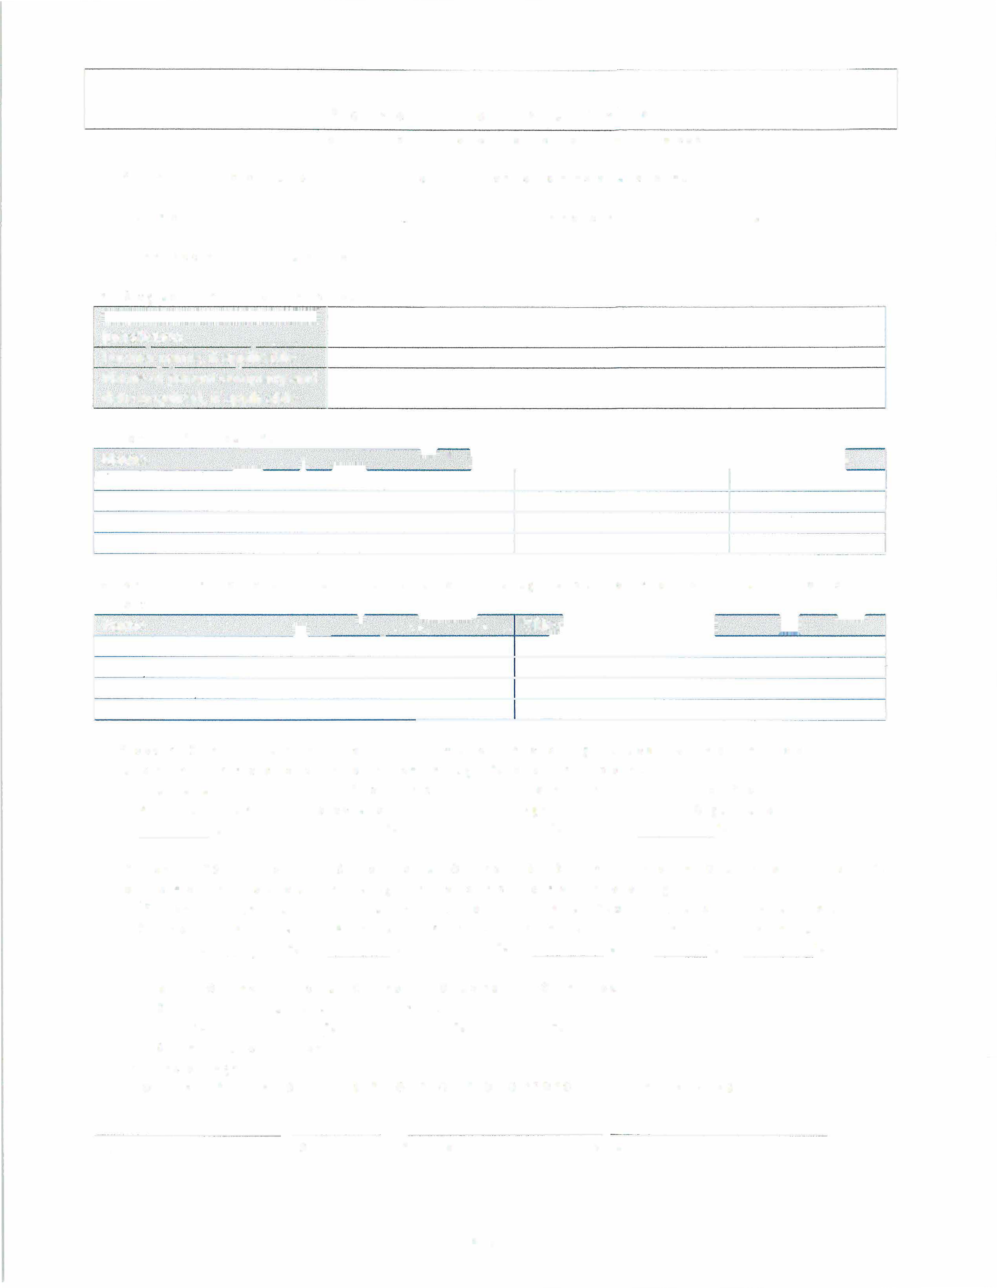
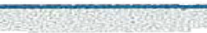
(NOTE: A CERTIFICATION/NUMBER NOT REQUIRED TO PROPOSE - ENTER IF AVAILABLE)

Signature Date Printed Name Company

Page 1

Federal Tax ID No.:

- Business License No.: Issuing State: _

- State of License Type and No.: _

- Worker's Compensation Insurance Carrier:------------,-_...., _

Policy No.: Expiration Date: _

- General Liability Insurance Carrier:--
-----'---------------------

PoIicy No. Expiration Date: _

- Professional Liability Insurance Carrier: _

Policy No.
Expiration Date:_
_ __
_ _ _ _ _
_ _ _ _

- Debarred Statement: Has this firm, or any principal(s) ever been debarred from providing any
services by the Federal Government, any state government, the State of New York, or any local government agency within or without the State of ? Yes D No
□
If ''Yes," please attach a full detailed explanation, including dates, circumstances and current status.

- Disclosure Statement: Does this firm or any principals thereof have any current, past personal or professional relationship with any Commissioner or Officer of the HA? Yes D No
□
If ''Yes," please attach a full detailed explanation, including dates, circumstances and current status.

- Non-Collusive Affidavit: The undersigned party submitting this proposal hereby certifies that such proposal is genuine and not collusive and that said proposer entity has not colluded, conspired, connived or agreed, directly or indirectly, with any proposer or person, to put ,jn a sham proposal or to refrain from proposing, and has not in any manner, directly or indirectly sought by agreement or collusion, or communication or conference, with any person, to fix the proposal price of affiant or of any other proposer, to fix overhead, profit or cost element of said proposal price, or that of any other proposer or to secure any advantage against the HA or any person interested in the proposed contract; and that all statements in said proposal are true.

- Verification Statement: The undersigned proposer hereby states that by completing and submitting this form he/she is verifying that all information provided herein is, to the best of his/her knowledge, true and accurate, and agrees that if the HA discovers that any information entered herein is false, that shall entitle the HA to not consider nor make award or to cancel any award with the undersigned party.

Signature Date

Printed Name Company

Page 2

WHITE PLAINS HOUSING AUTHORITY
Section 3 Contractor Certification (Attachment B)

I certify that the firm of _______________ (name of contractor)

IS
is not
a bonafide Section 3 Business Concern, and that it meets the following definition of a Section 3 Business concern (check one).

Low
51 percent 01· more of the company is owned by Section 3 residents. A Section 3 resident is (a) a public housing resident, or (b) a low or very low-income person residing in Ulster County; OR
At least 30% of its full-time employees include persons that are cun·ently Section 3 residents, or within three years of the date of first employment with the business concern were Section 3 residents; OR
Provides evidence, as required, of a commitment to subcontract in excess of 25 percent of the dollar award of all subcontracts to be awarded to business concerns that meet the qualifications in the above two paragraphs.
01� very low-income is defined below:

INCOME LEVELS: FY 2018
Median Family Income $117,100 (effective 4/14/2018)
# In Household | 1 | 2 | 3 | 4 | 5 6 | 7 | 8
Extremely Low (30%) | 24,650 | 28,150 | 31,650 | 35,150 | 38,000 40,800 | 43,600 | 46,400
Very low (50%) | 41,000 | 46,850 | 52,700 | 58,550 | 63,250 67,950 | 72,650 | 77,300
low (80%) | 55,100 | 62,950 | 70,800 | 78,650 | 84,950 91,250 | 97,550 | 103,850

Signature of Chief Executive Officer/Owner

Date

WHITE PLAINS HOUSING AUTHORITY
Location of Work (Attachment C)

Location of Work

Brookfield Commons: 223 Dr. Martin Luther King Jr. Blvd.
Central Offices 17 Offices
2 Staff Kitchens
1 Community Room

225 Dr. Martin Luther King Jr. Blvd
49 – 2 bedroom apartments
25 – 3 bedroom apartments
16 – 1 bedroom apartments 1 – Laundry Room
1 – Compactor Room Basement Maintenance Areas

11 Fisher Avenue
49 – 2 bedroom apartments
25 – 3 bedroom apartments
16 – 1 bedroom apartments 1 – Laundry Room
1 – Compactor Room Basement Maintenance Areas

33 Fisher Avenue
49 – 2 bedroom apartments
25 – 3 bedroom apartments
16 – 1 bedroom apartments 1 – Laundry Room
1 – Compactor Room Basement Maintenance Areas

